Reg. No. CODE: SPH2
PH. D COURSEWORK EXAMINATION, MAY 2023
SUBJECT: MATHEMATICS
SPECIALIZATION PAPER 2 - ADVANCED OPERATIONS RESEARCH

Time: 03 hours Maximum Marks: 50
Name: Mr. Veeresh Malagi and Ms. Apoorva

Instructions:
- Section A Compulsory
- Answer any four from Section B
- Each question carries 10 Marks
SECTION A

Answer the following question: (10 Marks)

- Consider the following transportation problem involving four sources and five destinations. The cell entries represent the cost of transportation per unit.

 | D1 | D2 | D3 | D4 | D5 | Supply
S1 | 10 | 2 | 16 | 14 | 10 | 300
S2 | 6 | 18 | 12 | 13 | 16 | 500
S3 | 8 | 4 | 14 | 12 | 10 | 825
S4 | 14 | 22 | 20 | 8 | 18 | 375
Demand | 350 | 400 | 250 | 150 | 400

Obtain the initial basic feasible solution using Vogel’s approximation method and hence optimize it by using MODI/ (U-V) method.

SECTION B

Answer any four from the following questions: (Each carrying 10 Marks)

2. Solve the following Assignment problem optimally using Hungarian method. The matrix entries represent the project execution times in days.
Project
 |  | 1 | 2 | 3 | 4 | 5
Crew | 1 | 20 | 30 | 25 | 15 | 35
 | 2 | 25 | 10 | 40 | 12 | 28
 | 3 | 15 | 18 | 22 | 32 | 24
 | 4 | 29 | 8 | 34 | 10 | 40
 | 5 | 35 | 23 | 17 | 26 | 45

3. Minimize subject to using dynamic programming.
4. Explain the main components of Genetic Algorithm and draw its flow diagram.

5. There are 9 jobs, each of which has to go through the machine A and B in the order AB, Processing times in hours are given as

Jobs | 1 | 2 | 3 | 4 | 5 | 6 | 7 | 8 | 9
Machine A | 5 | 3 | 12 | 15 | 6 | 10 | 11 | 9 | 5
Machine B | 6 | 8 | 10 | 10 | 6 | 12 | 1 | 3 | 7
Determine a sequence of these jobs that will minimize the total elapsed time. Also, find idle time for Machines A and B.

6. Four jobs are to be processed on each of the 5 machines. Find the total minimum elapsed time if non- passing of jobs is permitted. Also, find the idle time for each machine.

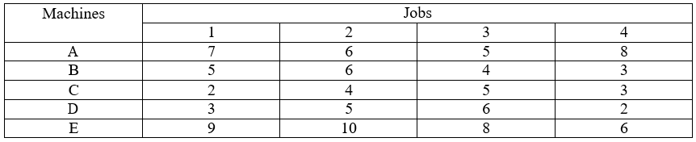

7. Find the optimal sequence and minimum elapsed time for given data using CDS algorithm.

 | Machines
Jobs | M1 | M2 | M3 | M4
J1 | 4 | 3 | 7 | 8
J2 | 3 | 7 | 2 | 5
J3 | 1 | 2 | 4 | 7
J4 | 3 | 4 | 3 | 2

********

